Binary Maze

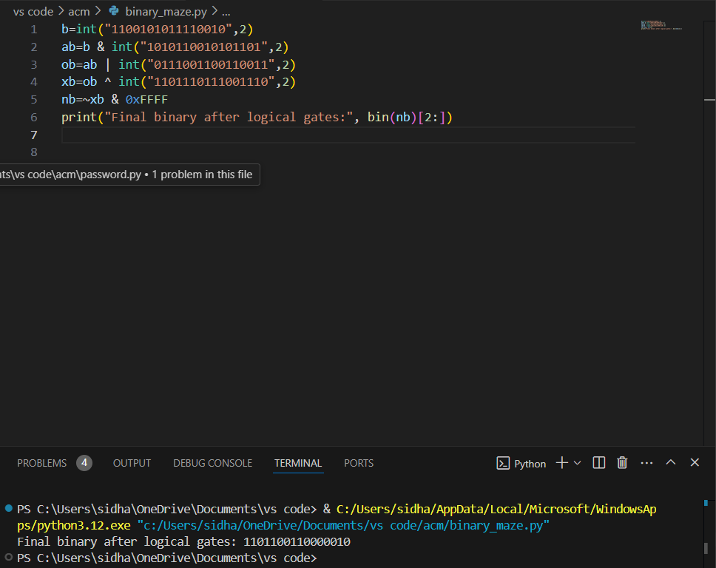

concerting 1101100110000010 to binary we get 55682

55682+123=55805*7=390635

Converting 390635 to binary we get 01011111010111101011

4. Weighted Binary Balancing

* **Compare Group A** (1001, 1100, 1110, 1010, 0111) against **Group B** (0101, 0011, 1111, 1101, 1011).

**Possible Outcomes:**

* **If Group A = Group B:**  
  The heavier weight is in **Group C**.
* **If Group A > Group B:**  
  The heavier weight is in **Group A**.
* **If Group B > Group A:**  
  The heavier weight is in **Group B**

Since Group A and Group B are equal, the heavier weight must be in **Group C**.

Compare 0110 (6), 0100 (4) against 0010 (2), 0001 (1)

**Possible Outcomes:**

* **If Equal:**  
  The heavier weight is the unknown ?.
* **If 0110 (6), 0100 (4) > 0010 (2), 0001 (1):**  
  The heavier weight is in 0110 (6) or 0100 (4).
* **If 0010 (2), 0001 (1) > 0110 (6), 0100 (4):**  
  The heavier weight is in 0010 (2) or 0001 (1).

Assume 0110 (6), 0100 (4) are Heavier,Then:

* • If **Group A = Group B** and within **Group C**, 0110 (6) and 0100 (4) are heavier, and 0110 (6) is heavier than 0100 (4), then:
* • **The heaviest binary number is the unknown heavier binary ?.**

10111 with an even number of 1s is 00011

**Flip 0s at positions [1, 3, 5]**: 11101011010100101110

**Flip 0s at positions [8, 10, 12]**: 11101111110100101110

**Flip 0s at positions [13, 15, 19]**: 11101111111111111111

The minimum number of moves required to make all bits 1 is **3**.You should flip the bits at positions [1, 3, 5], [8, 10, 12], and [13, 15, 19] in three separate moves.